Balachandran, Ryan 4/14/2022
Course Number: PHYS.1410L
Section Number: 804
Instructor: Dr. Mittler
Partners(s): Don’t know their names

Impulse and Momentum
Introduction
In this experiment, we are studying the forces of impulse and momentum during a collision. We can analyze the forces of collisions using the principle of conservation of linear momentum, but we will be directly measuring the forces during the collision compared to the change in the linear momentum. We will be studying the conservation of mechanical energy by comparing the kinetic energy of the car before and after the collision with the spring.

Theory
When studying Impulse and Momentum, we can transform Newton’s second law into the Impulse-Momentum theorem by first rewriting it in terms of linear momentum.
$$\vec{F}=m\vec{a}=m\frac{d\vec{v}}{dt}=\frac{d(m\vec{v})}{dt}=\frac{d\vec{p}}{dt}$$
In this form, Newton’s second law expresses that the net force on an object equals the rate of change of its linear momentum over change in time. Manipulating this equation can give us the Impulse-Momentum Theorem.
$$\vec{J}≡ \int_{t_{i}}^{t_{f}}{\vec{F}*dt= }\int_{t_{i}}^{t_{f}}{d\vec{p}=Δ\vec{p} }$$
With this, we can see that the impulse equals the area under the force vs. time curve and is also equal to the change in linear momentum, $Δ\vec{p}$. If the specific time dependence of the force is not known explicitly, then the relationship can be approximated as:
$$\vec{J}=\vec{{ F}_{ave}} Δt= Δ\vec{p}=mv_{f}-mv_{i}$$
In this experiment, there will be two types of mechanical energies involved; the kinetic energy of a moving cart and the elastic potential energy of a compressed spring.
The kinetic energy of an object can be defined as:
$$K=\frac{1}{2}mv^{2}$$
The elastic potential energy stored in a spring that is compressed or stretched is given by:
$$U_{sp}=\frac{1}{2}k{(Δx)}^{2}$$

Apparatus and Procedure
Materials:
- Force Sensor
- Motion Cart Transmitter
- Motion Cart Receiver
- Spring
- Air bag

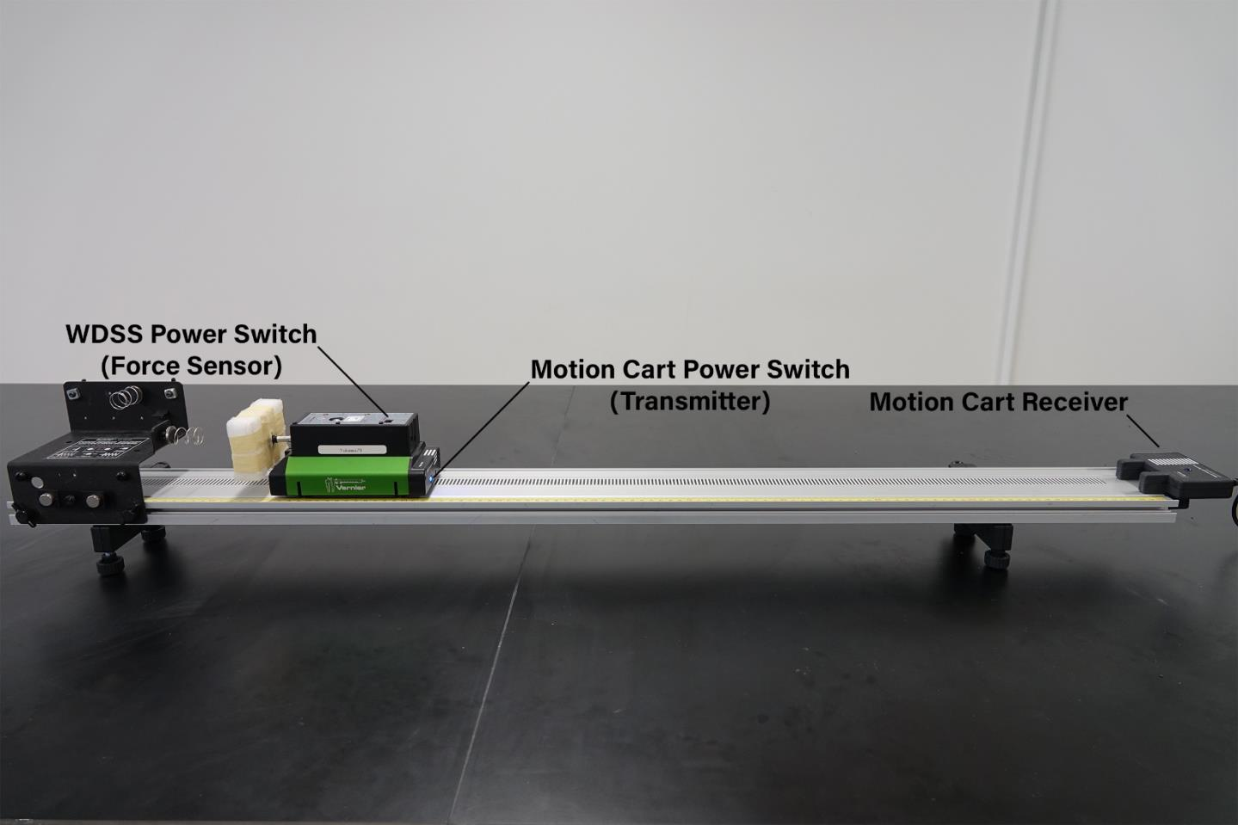

Procedure

For the experiment, there were 3 different parts where we split up into 2 teams of 3-4 people. The variables we were measuring were the mass of the car, the velocity of the cart before and after the collision, and the impulse in addition to the maximum force during the collision. We also were tasked with calculating the initial and final values for kinetic energy and momentum and comparing them.

Preliminary: Before we began, we used a balance to find the mass of the cart with the force sensor attached.

Part A: (light spring)
For this part, we screwed a light spring into the bracket to the left of the cart shown in the picture above. We took three runs where we held the end of the track so it wouldn’t move as we pushed the cart towards the spring, letting it hit the spring and rebound. We then made two graphs of velocity vs time and force vs time, with velocity being the maximum (initial) and minimum (final) velocities of the run and force being the initial and final momentum of the cart.

Part B: (air bag)
For this part we removed the spring and used a zip lock bag as an air bag. With a straw, we inflated it, leaving it open a few cm before taping it to the bracket. The goal for this part was to have the carts final velocity be zero without striking the bracket, this having a greater error in the change of kinetic energy than part a. To do this, we needed to adjust the opening of the bag and the speed of the cart. We recorded the maximum force for two runs, one with a small initial velocity and another with a large initial velocity.

Part C: (no air bag)
For this part we removed the air bag and recorded the maximum force for two runs that approximately match the initial velocities we used for part b.

Results and Data

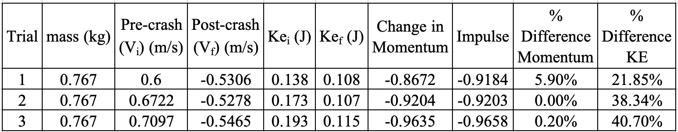
Table of all recorded values for part A (light spring)

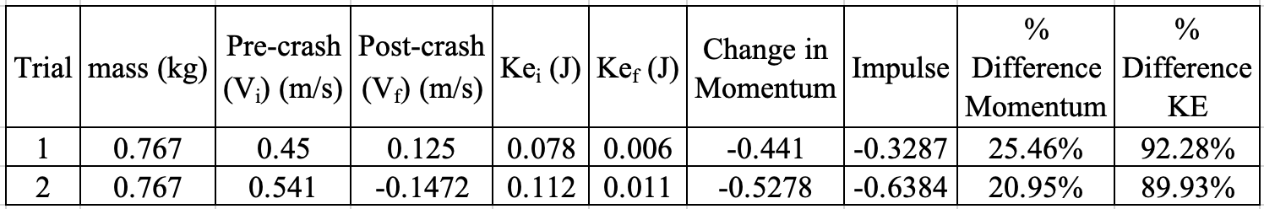
Table of all recorded values for part B (air bag)

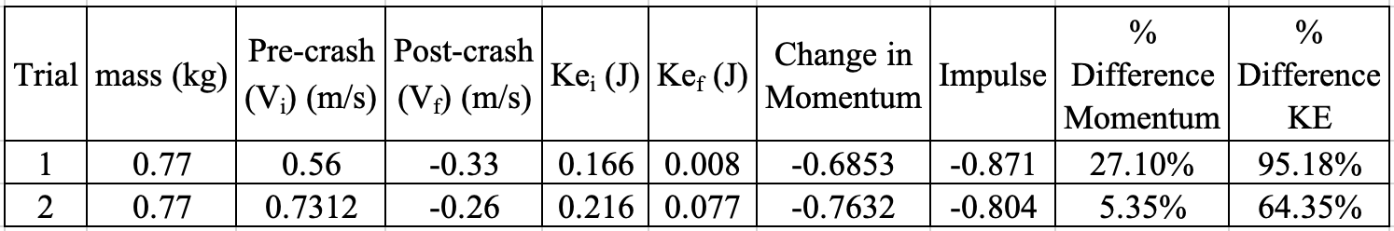
Table of all recorded values for part C (no air bag)

Analysis

(Note: I forgot to take pictures of the graphs, but I do know what they should look like).

Discussion

Part A: With the light spring, the % difference in momentum of the cart hitting the spring and rebounding was kept relatively low, while the different in kinetic energy was between 20-40%. The loss in kinetic energy was due to the energy being absorbed by the spring as the cart hit it. The momentum was conserved fairly well as the cart rebounded with slightly slower final velocity than its initial, although it was in the negative direction. For kinetic energy though, errors in how fast the cart was pushed and how well the track was held steady were responsible for any deviations made in what the proper difference in kinetic energy there were supposed to be.

Part B: With the air bag, the % difference in momentum was much greater, between 20 and 25% because the air bag absorbed the energy of the cart and released that air as the cart hit it, slowing the cart down to a stop. Without the spring, there was nothing to push the cart back, so it quickly came to a stop. The kinetic energy also proves this as the % difference in kinetic energy is between 89 and 92% in comparison with the initial kinetic energy and final kinetic energy. Any errors made in calculations were because of the difficulty of filling the air bag with the proper amount of air and pushing the cart with the right amount of force.

Part C: With no air bag, the % difference in momentum was close in the first run but 5% in the second run, though the % difference for kinetic energy stayed about the same. Having the cart hitting the rack with no spring or air bag, resulting in change in momentum and kinetic energy from outside forces proves the low of conservation of mechanical energy and the Impulse-momentum theorem hold true, as the momentum and kinetic energy from the cart were almost completely absorbed by the rack with little to no force pushing the cart back.

Conclusion

The overall goal of the experiment was to study the effects of the change in Impulse, Momentum and Kinetic energy during a crash and how well mechanical energy is conserved throughout. In an elastic collision, momentum and impulse are relatively well preserved, with some of the objects kinetic energy being absorbed by the spring. With the air bag in an inelastic collision, the loss of kinetic energy was much larger because of a small intentional hole in the bag that let the air escape when the cart collided and stopped.

Questions

- A vehicle of mass $2.7 x {10}^{3}kg$ impacts an immovable test barrier and comes to a complete stop.
  - If the sensors on the barrier indicate an impulse of $6.3 x {10}^{4} N/s$ for the crash, determine the initial velocity of the vehicle in m/s and mi/h.

Given mass of vehicle and impulse. The equation for impulse is $J=mΔv$. Rearranging this, we get $Δv=\frac{J}{m}→ v_{f}-v_{i}=\frac{J}{m}$.

We can see that the final speed of the vehicle is zero as it comes to a stop, so by dividing the impulse by the mass, we can get the initial speed of the vehicle.

$$v_{i}=\frac{J}{m}=\frac{6.3 x {10}^{4}\frac{N}{s}}{2.7 x {10}^{3}kg}=23.3 m/s$$

Since N/s (newton second) in SI units is kg*m/s, kg cancels out, leaving m/s.
23.3 m/s in mi/h is 52.12 mi/h. Since 0.44704 m/s is in 1 mi/

  - If the crash lasts for $3.5 x {10}^{-3} s$, determine the average force (in N and lb) on the vehicle.

To find the average force, we simply take the change in velocity and divide it by time.

$F_{ave}=\frac{mv_{f}-mv_{i}}{Δt}=\frac{0-23.3}{3.5 x {10}^{-3}}=-6,657.14 N$ or -1,49658 pounds of force

- A ball is projected at an immovable wall with a speed $v_{i}$ and bounces back the wall in such a manner that it only has 1/3 of its original linear momentum.
  - Determine what fraction of the kinetic energy is lost in the collision.

Initial speed of the ball is $v_{i}$
Final momentum of the ball is $P_{f}=\frac{1}{3}p_{i}$

Initial and final momentum of the ball is calculated as:
$$P_{i}=m_{i}v_{i}$$
$$P_{f}=m_{f}v_{f}=\frac{1}{3}m_{i}v_{i}$$

Initial and final Kinetic energy of the ball is calculated as:
$${KE}_{i}={\frac{1}{2}m}_{i}{v_{i}}^{2}=\frac{1}{2}P_{i}v_{i}$$
$${KE}_{f}={\frac{1}{2}m}_{f}{v_{f}}^{2}=\frac{1}{2}\left(\frac{1}{3}P_{i}v_{i}\right)=\frac{1}{6}P_{i}v_{i}$$
The change in kinetic energy is calculated as:
$$ΔKE={KE}_{f}-{KE}_{i}$$
$$ΔKE=\frac{1}{6}P_{i}v_{i}-\frac{1}{2}P_{i}v_{i}=\frac{1}{3}P_{i}v_{i}$$

The fraction of the kinetic energy of the ball lost during the collision is $\frac{1}{3}.$

  - What happened to the kinetic energy that was lost?

The immovable wall absorbed the kinetic energy.

